**LAB ASSIGNMENTS 1: Linux command On EC2 instance**

System and hardware informatation

File and Directory Commands

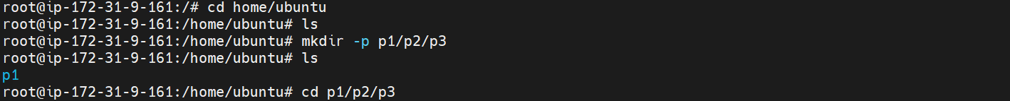

file editing and navigation inside files

Piping and i/o redirection

Wildcard chars

Services and Process mgt

file permission

